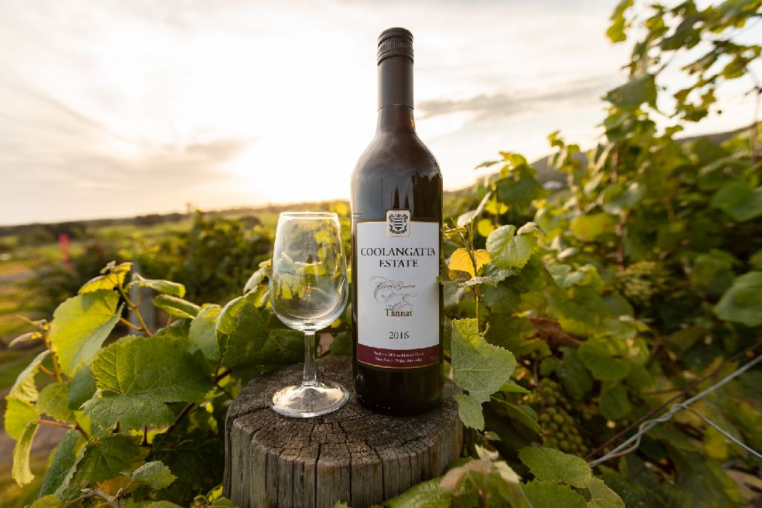
Sunbeam National Rally 9-12 September, 2022
Coolangatta: on the beautiful NSW South Coast

REGISTRATION FORM (complete one form per vehicle or family)

Booking in the name(s) of:

Address:

STATE: | Telephone:
Email

Name(s) of Persons attending (as it will appear on name tag)
1 | 2
3 | 4
DRIVER/VEHICLE DETAILS:
Driver: | Year:
Make: | Colour:
Model: | Reg No.

If you pay your $200 Registration fee by direct deposit into our club’s bank account, include your SURNAME as payment reference - account details below:

SUNBEAM OWNERS CLUB | REF: (Your surname)
BSB No: 062 204 | Account No: 10005837

PAYMENT OPTIONS:

I have paid DEPOSIT for entertainment package __ persons at $100 person

I have paid IN FULL for entertainment package __ persons at $200 person

Total amount enclosed: $ _____ BALANCE PAYABLE BY JUNE 30, 2022

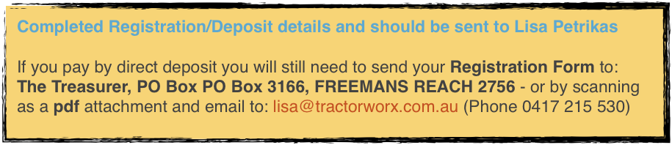
HURRY!: Early booking & payment will reserve your place. First in best dressed!

MEALS & Dietary/Medical requirements:

*Further details of activities and options will be sent out prior to the event.
NAME: |  | NAME:
X | (Please place ‘X’ next to any special dietary or medical requirements):
 | Diabetic |  | Diabetic
 | Vegetarian |  | Vegetarian
 | Gluten Free |  | Gluten Free
 | Vegan |  | Vegan
 | Nut allergy |  | Nut allergy
 | Other special medical or dietary requirements. |  | SPECIFY:

I will be staying at:
o Coolangatta Estate
o Mountain View Resort
o The Berry Inn
o Other PLEASE SPECIFY: ______________________________________

* Accommodation must be booked & paid directly with hotel/resort

ENQUIRIES:
President David Petrikas 0408 636 414 david@prstrategy.com.au
Treasurer Lisa Petrikas 0417 215 530 lisa@tractorworx.com.au
Events coordinator Roy Segrott 02 9871 6357 segrotts@optusnet.com.au
Committee member Martin Clarke 0423 633 133 mountclarke@gmail.com

RECOMMACCOMMODATION OPTIONS:

Coolangatta Estate* *FULLY BOOKED*
(*‘SUNBEAM’ booking Includes 3 nights accommodation& buffet breakfasts).

CONTACT: Coolangatta Estate:
1335 Bolong Road Shoalhaven Heads, 2535
Phone: 02 4448 7131 Web: www.coolangattaestate.com.au

Mountain View Resort (VERY CLOSE BY))
*Ask for ‘SUNBEAM’ booking: Also one 3 bedroom luxury cabin also available sleeps 6

CONTACT: Mountain View Resort:
14 Shoalhaven Heads Road Shoalhaven Heads, 2535
Phone: 02 4448 7281 Web: mtview.com.au

The Berry Inn 3-night luxury accommodation package Queen room*

CONTACT: The Berry Inn
Kirsty or Aaron: info@berryinn.com.au
17 Prince Alfred St Berry NSW 2535
Phone: 02 4464 2064 Web: www.berryinn.com.au

OTHER ACCOMMODATION OPTIONS (subject to availability)

Mercure Gerringong Resort

CONTACT: Mercure Gerringong Resort:
1 Fern Street Gerringong 2534
Toll Free: 02 4234 1359 Web: mercuregerringong.com.au

Park Ridge Retreat *

CONTACT: Park Ridge Retreat:
139 Belinda Street, Gerringong 2534
Phone: 02 4234 1000 Web: parkridgeretreat.com.au

QUEST Nowra **NOTE: 10% discount for Quest Online Advantage members

CONTACT: QUEST Nowra:
130 Kinghorne Street, Nowra 2541
Phone 02 4421 9300 Web: questapartments.com.au
